Chapter 7: Surviving

7.1 The human body is divided into systems

Student worksheet answers (pages 116–117)

Human body systems

1 Use the list below to identify which organs are involved in each system:

|  |  |  |  |  |  |  |  |
| --- | --- | --- | --- | --- | --- | --- | --- |
| *Brain* | *Nose* | *Muscles* | | *Blood* | *Stomach* | | *Mouth* |
| *Lungs* | *Small*  *Intestine* | *Heart* | | *Diaphragm* | *Oesophagus* | | *Large intestine* |
| *Liver* | *Veins* | *Spinal cord* | | *Windpipe* | *Bones* | | *Nerves* |
| Bones | | | Brain  Nerves  Spinal cord | | | Heart  Veins  Blood | |
| SKELETAL SYSTEM | | | NERVOUS SYSTEM | | | CIRCULATORY SYSTEM | |
| Lungs  Windpipe  Nose  Mouth  Diaphragm | | | Oesophagus  Stomach  Mouth  Liver  Small intestine  Large intestine | | | Muscles  Bones | |
| RESPIRATORY SYSTEM | | | DIGESTIVE SYSTEM | | | MUSCLE SYSTEM | |

2 Draw a flowchart that depicts the pathway from cells to body systems.

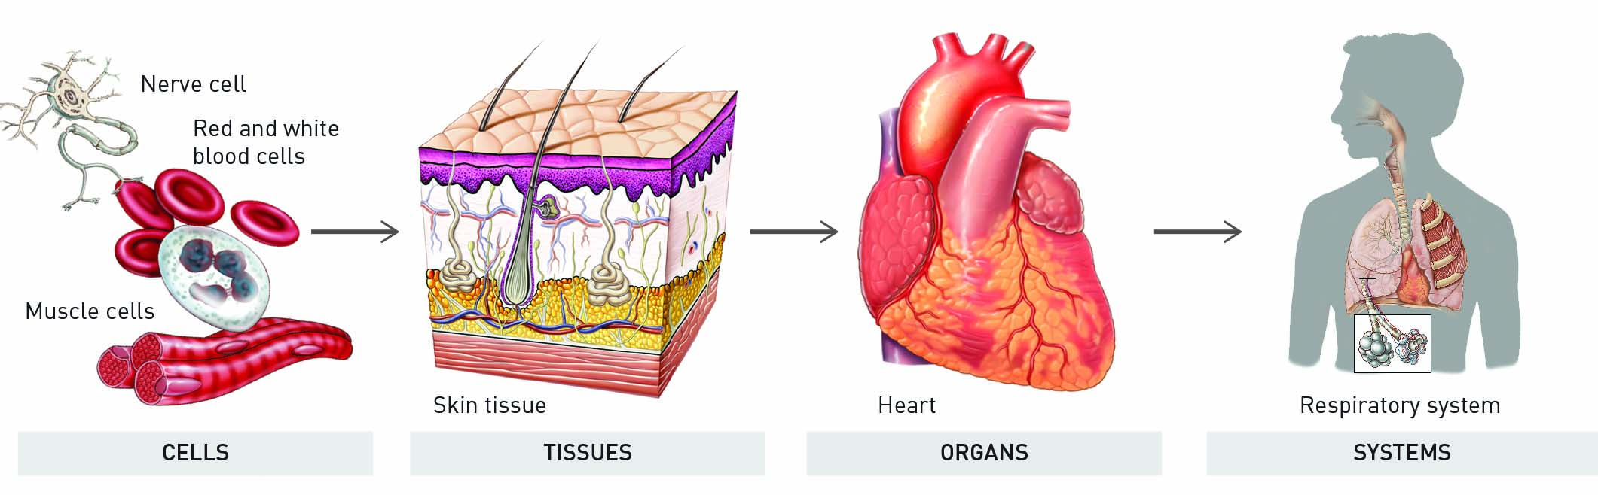

3 When and where did the first scientists to study anatomy live?

Alexandria in 300 BC

4 Why did they perform dissections?

To investigate how the human body worked

5 What is involved in the mummification process?

To prepare corpses for burial, key organs were removed from the body as they interfered with mummification

6 How did da Vinci start his studies on anatomy?

He was involved in human and animal dissections and drew beautiful and highly accurate drawings. He was very curious about the way things worked and left hundreds of papers on the human body.

7 What was da Vinci able to model from his investigations of the heart?

The aortic valve – the one-way valve in the main artery of the heart, using glass

8 What would da Vinci have discovered if he had finished his work?

How blood circulates around the body

9 What is a corpse?

A lifeless organism, specifically a human being

10 In the 1700s, how were bodies obtained for medical students to perform dissections?

Anatomists paid gangs to steal bodies from graveyards

11 List three advances that occurred due to the improvement in medical care of the 1700s.

*Answers may vary.* Development of the smallpox vaccine; safer childbirth; improved dental surgery techniques

Extend your understanding

12 How do you know that each of your body systems is working? Using your general knowledge, state three things that occur on a daily basis that proves that each of these six body systems is working.

|  |  |
| --- | --- |
| Answers will vary  Standing upright; anything that involves the ability to keep the body upright and not fall due to gravity | Answers will vary  Movement of the body parts, especially in response to a stimulus  The brain making any part of the body move |
| SKELETAL SYSTEM | NERVOUS SYSTEM |
| Answers will vary  Blood flow around the body  Cutting yourself and bleeding  Feeling your pulse/heart beat  Seeing your veins pump through your skin | Answers will vary  Breathing  Movement of diaphragm due to breathing  Holding your breath and needing air |
| CIRCULATORY SYSTEM | RESPIRATORY SYSTEM |
| Answers will vary  Stomach growling  Eating/drinking  Using the toilet  Stomach aches  Heartburn | Answers will vary  Ability to move  Lifting weights  Exercise |
| DIGESTIVE SYSTEM | MUSCLE SYSTEM |

7.2 The digestive system is made up of organs

Student worksheet answers (pages 118–119)

The digestive system

1 What is digestion?

When foods are broken down and absorbed into the blood to be transported to the cells

2 What are nutrients?

Substances that provide nourishment, which is essential for the maintenance of life and for growth

3 How do nutrients travel to where they are needed within the body?

The blood pushes nutrients through the body

4 What is chemical digestion? Give an example.

The breakdown of foods by enzymes and acids; for example, saliva contains enzymes that start chemical digestion

5 What is mechanical digestion? Give an example.

Organs work as machines, physically breaking food into smaller pieces; for example, mouth/teeth

6 Label the following diagram of the mouth.

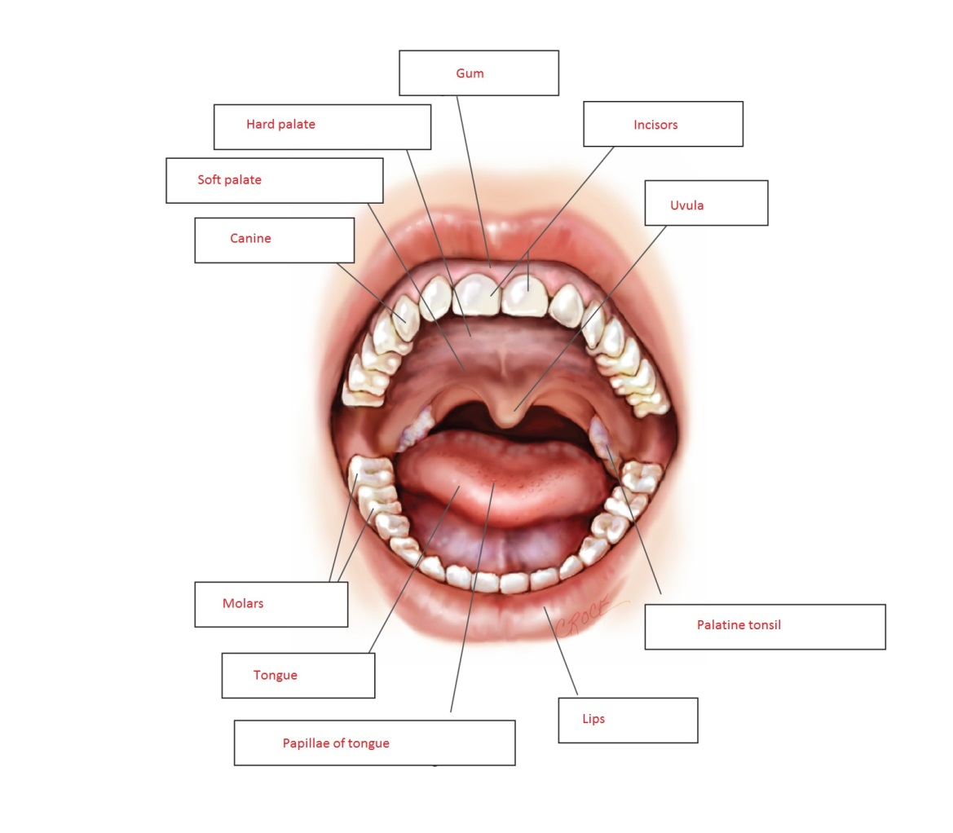

7 Label the following diagram of the digestive system.

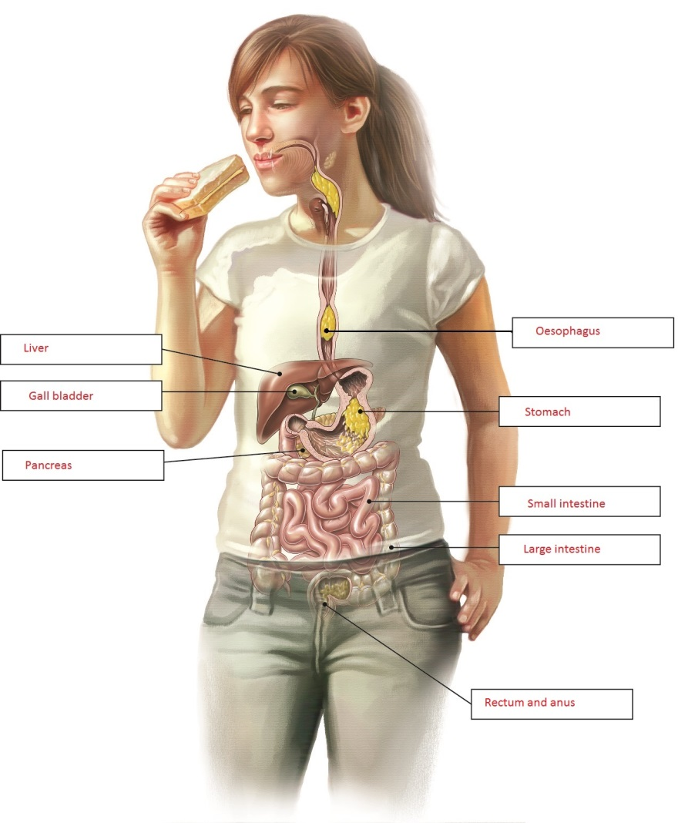

8 Match the organ with its function.

|  |  |
| --- | --- |
| **ORGAN** | **FUNCTION** |
| 1 Stomach | E Stores food for about three hours while it uses gastric juice to help digest it |
| 2 Liver and gall bladder | H Makes a mixture of chemicals called bile, which is used to digest fat and neutralise (deactivate) stomach acid |
| 3 Mouth | G Location of salivary glands that make saliva, which contains enzymes to start chemical digestion |
| 4 Rectum and anus | D Stores faeces until it starts to become full, then pushes the faeces out of a ring of muscle |
| 5 Large intestine | F Where water and some vitamin absorption occurs; it is the body’s last chance to absorb nutrients |
| 6 Oesophagus | B Tubular muscle that forces food down to your stomach in a process called peristalsis |
| 7 Pancreas | A Makes a type of juice that contains a mixture of digestive enzymes, and also neutralises stomach acid |
| 8 Small intestine | C Absorbs nutrients that feed all cells of the body; villi help to increase the surface area of this organ for better absorption |

Extend your understanding

9 The human body contains enzymes to aid in the chemical breakdown of foods. What is an enzyme?

A substance produced by living organisms that helps make chemical reactions happen

10 Research the following five enzymes: *amylase, pepsin, protease, lactase, lipase*From what you have learned, complete the following sentences by matching each enzyme with its function and correct organ in the digestive system:

a Amylase is able to break down starch into sugars and is found in the mouth and small intestine

b Pepsin is able to break down proteins into amino acids and is found in the stomach

c Protease is able to break down proteins into amino acids and is found in the stomach and small intestine

d Lactase is able to break down lactose into smaller sugars (glucose and galactose) and is found in the small intestine

e Lipase is able to break down fats and oils into fatty acids and glycerol and is found in the small intestine

11 What is the function of bile?

It is secreted into the small intestine where it emulsifies (breaks down) fats and neutralises   
stomach acid

12 Why is bile not considered to be an enzyme?

It is alkaline (a base), which neutralises highly acidic stomach acid. Once it has been neutralised, the remaining enzymes are able to work. Bile helps enzymes to work better.

7.3 The digestive system varies between animals

Student worksheet answers (pages 120–121)

The digestive systems of various animals

1 What is the function of the each of the different types of teeth?

Incisors have a sharp knife-like structure, and are used to cut through food.

Canine teeth are pointed and are useful in ripping lumps of meat apart.

Molars are flatter and are especially good at grinding plants into small pieces.

2 How would a palaeontologist be able to tell if an animal was a carnivore, herbivore or omnivore?

By looking at their teeth to see what they ate

3 Are humans categorised as carnivores, herbivores or omnivores? How can you tell?

Omnivores. Humans have all three types of teeth, implying we eat meet and plants.

4 What is the function of the caecum?

It is a dead-end pouch where food (plant material) is stored until bacteria can break down the cellulose

5 Why would animals have a caecum?

They do not make the protein cellulase that breaks down the cellulose in plant material

6 What is the problem with the position of the caecum on the digestive tract? How do some animals overcome this problem?

Plant matter is digested after it passes through the small intestine, the location where the nutrients are absorbed. Animals eat their own faeces to get the extra nutrients that were missed the first time through their digestive tract.

7 What is the major difference between a cow’s and a human’s digestive system?

A cow has four stomachs and a human has only one

8 What is a ruminant?

An animal that converts grass and other foods into protein and energy using a four-compartment stomach

9 What other animals are ruminants?

Sheep and goats

10 Using the information on page 121 of your student book and your knowledge of the function of digestive organs, match the organ involved in a cow’s digestive system with its function.

|  |  |
| --- | --- |
| **Organ** | **Function** |
| 1 Omasum | H Third compartment of the stomach: cud is pressed and reduced in size |
| 2 Rumen | E First compartment of the stomach: grass is softened by fluids |
| 3 Small intestine | A Absorption of chemicals into the blood stream |
| 4 Oesophagus | B Chewed grass moves through this pathway to the next organ |
| 5 Udder | D Contains the milk in cows that have given birth to a calf |
| 6 Abomasum | G Fourth compartment of the stomach: breaks food down into biomolecules (protein, vitamins, simple carbohydrates, fats and amino acids) |
| 7 Large intestine | F Absorbs, re-circulates and conserves water and minerals |
| 8 Reticulum | C Second compartment of the stomach: grass is softened and clumps together to form cud |

Extend your understanding

The udder contains the milk in cows that have given birth to a calf. It takes up to 70 hours for a cow to turn grass into milk. For every litre of milk a cow makes, more than 400 litres of blood must travel around her udder to deliver the nutrients from the grass. Australian dairy cows produce about 15 litres of milk a day.

11 If a cow produces 15 litres of milk per day, how much blood must travel around their udder each day?

1 L of milk = 400 L of blood. Therefore, 15L of milk = 15 ´ 400 L = 6000 L of blood per day

12 How much milk is a female cow capable of producing in one year?

1 day = 15 L, therefore 365 days = 15 ´ 365 = 5475 L of milk each year

13 How much milk are 100 female cows capable of producing in one year?

1 cow = 5475 L of milk each year, therefore 100 cows = 5475 ´ 100 = 547 500 L of milk each year

14 A farmer has 100 cows on a farm. If she wants to produce 684 375 litres of milk each year, how many more cows will she need to purchase?

684 375L – 547 500L = 136 875 L difference.

136 875 L / 365 days = 375 / 15 L per day = 25 cows

7.4 Science as a human endeavour: Things sometimes go wrong in the digestive system

Student worksheet answers (pages 122–123)

Problems in the digestive system

Stomach ulcers

1 In which digestive organ do stomach ulcers form?

Stomach

2 What is the cause of stomach ulcers?

Spiral-shaped bacteria called *Helicobacter pylori* cause damage to the cells lining the stomach. The pain comes from the stomach acid burning the other tissues around the ulcer.

3 What effect does a stomach ulcer have on your body?

A great deal of pain in your stomach

4 What is the treatment for stomach ulcers?

Antibiotics, to kill the bacteria causing the stomach ulcer

5 Who first developed this treatment and what were they awarded for their efforts?

Australian scientists Barry Marshall and Robin Warren; they were awarded a Nobel Prize in 2005

Gallstones

6 In which digestive organ do gallstones form?

Gall bladder

7 What is the cause of gallstones?

Bile hardens into a small stone that stops the bile leaving the gall bladder. The amount of bile in the pouch increases, causing the gall bladder to swell up.

8 What effect does a gallstone have on your body?

Severe stomach pains

9 What is the treatment for gallstones?

The stones are shattered by ultrasound or removed by surgery

Gluten intolerance

10 What are the symptoms of gluten intolerance?

Blockages of the intestines and diarrhoea (watery faeces)

11 What is the cause of gluten intolerance?

The body is unable to produce the enzyme that breaks down gluten

12 What effect does gluten intolerance have on your body?

Gluten cannot be digested and causes stomach pains, blockages and diarrhoea

13 What is the treatment for gluten intolerance?

Do not eat gluten

Constipation

14 In which digestive organ does constipation occur?

Large intestine

15 What is the cause of constipation?

Blockages in the large intestine due to poor diet (lack of fruit and vegetables) or by an infection

16 What effect does constipation have on your body?

Severe abdominal cramps/pain/discomfort

17 What is the treatment for constipation? What may happen if it is left untreated?

Sometimes medication is needed to move the blockage; untreated, the person may die.

Extend your understanding

18 Choose one of the three digestional problems below and answer the following questions.

Heart burn/reflux Lactose intolerance Crohn’s disease

|  |  |  |  |
| --- | --- | --- | --- |
|  | **Heart Burn/Reflux** | **Lactose Intolerance** | **Crohn’s Disease** |
| a What is the cause and the digestive organ responsible for this condition? | Stomach acid rises into the oesophagus and mouth | Body is unable to digest milk sugars (lactose) in the Small intestine because the body does not produce the enzyme lactase | Inflammation of the bowel in the lower small intestine (ileum) and the large intestine (colon), but may involve any part of the digestive tract from the mouth to the anus  Cause of inflammation unknown – possibly bacteria or immune disorders |
| b What effects can this condition have on your body? | Burns the throat and mouth | Gas, stomach pains, bloating and diarrhoea | Abdominal pain and diarrhoea  Rectal bleeding, loss of appetite, fever and weight loss may also occur |
| c What is the treatment? | Medication that neutralises acids – they are usually made of bases (you could dissolve bicarb soda in water and drink it) | Limit the amount of milk and milk products in your diet | Either immunosuppressive agents or antibiotics |
| d Is there any way to manage the condition to avoid it happening again or to limit ongoing effects? | Avoid certain foods, eat smaller meals, avoid alcohol and caffeine, stop smoking, lose weight, avoid aspirin | There is no cure  You must limit the amount of milk and milk products in your diet for life | There is no cure  Patients must rely on ongoing treatment of symptoms |

7.5 The respiratory system exchanges gases

Student worksheet answers (pages 124–125)

The respiratory system

1 What is the function of the respiratory system?

To give the cells in your body the oxygen they need, and to remove carbon dioxide

2 What is cellular respiration and why is it important?

The process that releases energy from glucose, and requires oxygen; most of the food we eat is broken down to glucose, so the energy must be released from the glucose via cellular respiration

3 Describe the path that oxygen takes through the mouth and into the blood.

Through the mouth/nose to the pharynx, then through the oesophagus, trachea, lungs and alveoli, then into the blood

4 What is the structure and function of alveoli?

They are air sacs within the lungs that are covered in capillaries and transport oxygen into the blood

5 Why do capillaries cover each alveolus?

Capillaries are very small and are able to wrap closely around the alveolus, allowing for better gas exchange

6 Why do some capillaries appear to be red and others appear to be blue?

Red = oxygenated blood; blue = deoxygenated (carbon dioxide-rich) blood

7 What is the structure and function of the diaphragm?

A dome-shaped muscle that lifts the rib cage to allow the lungs to fill with air and deflate

8 Explain the movement of the diaphragm when inhaling and exhaling.

While inhaling, the diaphragm relaxes up to allow lungs to inflate

While exhaling, the diaphragm contracts down to squeeze air out of the lungs, allowing deflation

9 What is the function of the ring of cartilage that surrounds the trachea (windpipe)?

It acts as structural support to keep the windpipe open and protect it against damage

10 Label the following diagram of the respiratory system.

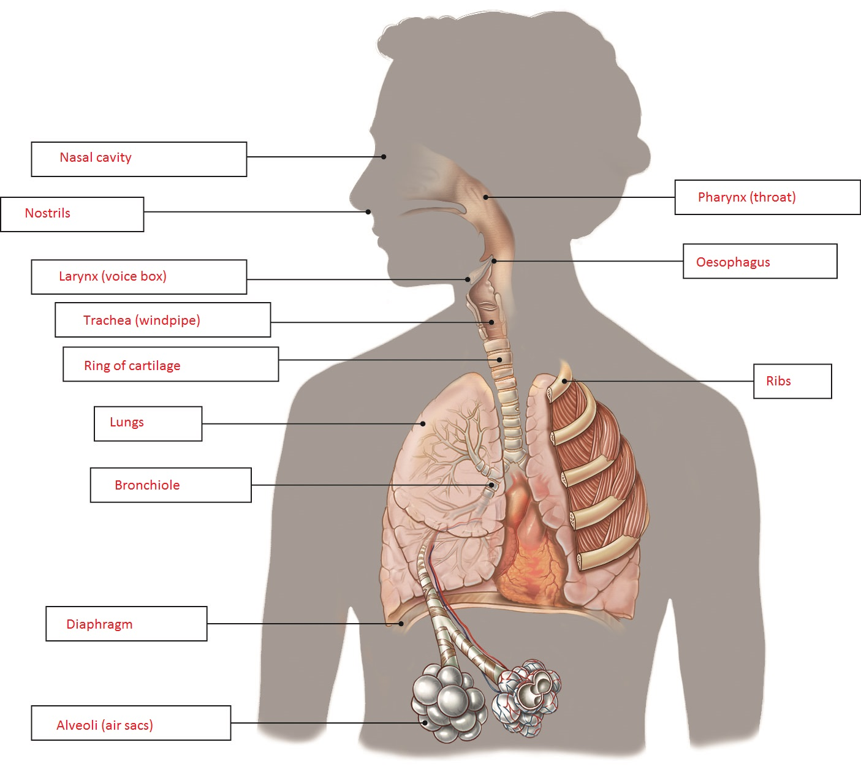

Extend your understanding

Plants have an alternative system of exchanging gases.

11 Why is the plant exchange of gases called respiration rather than breathing?

The term ‘breathing’ is used for respiration with lungs; respiration refers to an exchange of gases

12 What is the name of the process that plants use to convert carbon dioxide into sugars? Write an equation for this process.

Photosynthesis

CO2 + H2O ® C6H12O6 + O2

13 Which gas do plants use in this reaction, and which gas is released as waste?

Carbon dioxide is used in photosynthesis; oxygen is released as waste

14 What is the name of the organ within a leaf where this process occurs?

Chloroplast

15 What is the name of the pigment that is necessary for this process and what colour is it?

Chlorophyll; green

16 Why are plants green?

They are green due to the chlorophyll in chloroplasts where photosynthesis occurs

7.6 Science as a human endeavour: Things sometimes go wrong in the respiratory system

Student worksheet answers (pages 126–127)

Problems in the respiratory system

Coughing and sneezing

1 In which respiratory organ does coughing and sneezing occur?

Organs of upper airways – nose and throat

2 What is the cause of coughing?

Small cilia trap larger particles and want to push them back to the top of the throat to be swallowed. The diaphragm contacts quickly in response to the large particles, making us cough them up.

3 What is the cause of sneezing?

Small cilia trap smaller particles in the nose, sending a message to the brain that tells organs to sneeze

4 How fast are some sneezes?

Up to 120 kilometres per hour

Asthma

5 How many Australians are affected by asthma?

1 in every 10 Australians

6 In which respiratory organ does asthma occur?

Bronchi and bronchioles

7 What is the cause of asthma?

Something in the environment irritates the airways causing the bronchi and bronchioles to narrow and making it harder for air to move into the lungs

8 What effect does asthma have on your body?

Makes it harder to breathe

9 What is the treatment for asthma?

A drug called Ventolin is used to relax the airways

Emphysema

10 In which respiratory organ does emphysema occur?

Lungs

11 What is the main cause of emphysema?

Smoking tobacco. Smoking breathes tar into your lungs. The tar covers the inside of the alveoli like honey, stopping oxygen from moving into the blood. Alveolar sacs are killed by chemicals, and the body is not able to move air in and out.

12 What effect does emphysema have on your body?

Makes it a struggle to breathe, and therefore difficult to walk even short distances

13 What is a treatment for emphysema?

Stop smoking – quit!

Pneumonia

14 In which respiratory organ does pneumonia occur?

Lungs

15 What is the cause of pneumonia?

A bacterial or viral infection where alveoli in the lungs fill up with bacteria, pus and fluid, which prevents air moving into the lungs

16 What effect does pneumonia have on your body?

Makes it very difficult to breathe, sometimes resulting in death if not treated

17 What is the treatment for pneumonia?

Antibiotics to kill the bacteria

Extend your understanding

18 Choose one of the three respiratory conditions below and answer the following questions.

Hayfever Chronic obstructive pulmonary disease (COPD) Cystic fibrosis

|  |  |  |  |
| --- | --- | --- | --- |
|  | **Hayfever** | **COPD** | **Cystic Fibrosis** |
| a In which respiratory organ does the condition occur? | Mouth, nose and throat | Lungs | Lungs and digestive system |
| b What is the cause of this condition? | An allergic response to airborne substances, such as pollen | Lung diseases such as emphysema, chronic bronchitis and chronic asthma  Weakening of alveoli and bronchi, and ruptured air sacs means they are unable to move oxygen into the blood | A genetic disorder where the CFTR gene does not work properly. It normally moves salts and water out of cells. |
| c What effects can this condition have on your body? | Sneezing, congestion | Prevents proper breathing – breathlessness, chronic cough and sputum production | Build-up of thick, sticky mucus in the body's tubes and passageways – difficulty breathing and coughing up sputum as a result of frequent lung infections |
| d What is the treatment? | Over-the-counter and prescription medications for treating hay fever symptoms, e.g. antihistamines | Medication to open airways, reduce inflammation and swelling of lung tissue, and loosen phlegm  Oxygen therapy is also possible | Physical therapy (chest clapping), exercise and medication to remove mucus from lungs |
| e Is there any way to manage the condition to avoid it happening again or to limit ongoing effects? | No cure  People are recommended to monitor pollen warnings and avoid going outside when it is high  Damp dusting, avoid pets with dander, avoid flowers | No cure  Symptoms worsen as disease worsens; only symptoms can be treated | No cure  Only treatment of symptoms |

7.7 The circulatory system carries substances around the body

Student worksheet answers (pages 128–129)

The circulatory system

1 What is the function of the circulatory system?

It moves blood around the body to transport nutrients and wastes

2 How many chambers are there in a human heart?

Four

3 What are the top chambers called?

Atriums

4 What are the bottom chambers called?

Ventricles

5 Which side pumps blood to the lungs?

Right side

6 Which side pumps blood around the body?

Left side

7 Why are the left side and the muscles surrounding it bigger than the right side?

The left side pumps blood around the body, which is a longer path than the lungs, therefore more muscle is required

8 Label the following diagram of the heart.

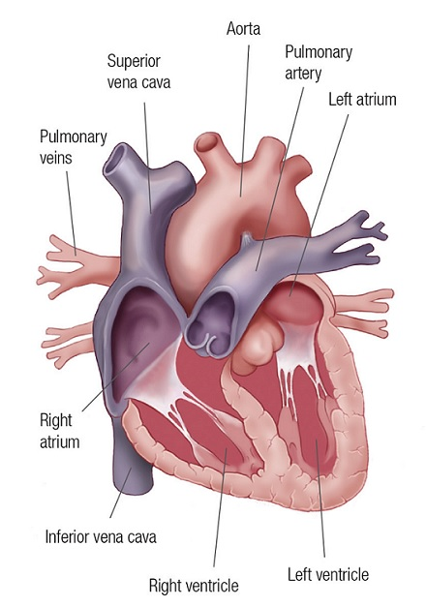

9 Match each component of blood to its function:

|  |  |
| --- | --- |
| **BLOOD COMPONENT** | **FUNCTION** |
| 1 Plasma | C Nutrients and wastes are dissolved in it for transport to and from cells |
| 2 White blood cells | D Germ fighters |
| 3 Haemoglobin | E Carries oxygen in red blood cells |
| 4 Platelets | A Cell fragments that travel in the blood to cuts to block the cuts and stop bleeding |
| 5 Red blood cells | B Carry oxygen to the body’s tissues and carbon dioxide away from them |

10 Which type of blood vessel carries blood toward the heart?

Veins

11 Which type of blood vessel carries blood away from the heart?

Arteries

12 Describe the structure and function of capillaries.

Capillaries are only one cell thick to allow substances to easily pass in and out of the blood

Extend your understanding

Animals have various adaptations that allow them to survive the effects of extreme weather conditions. Penguins stand on cold ice, sometimes for months on end, without losing feeling in their feet or getting frostbite. This is because penguins have two main adaptations that involve their circulatory system.

13 Research the following adaptations and explain how each occurs in terms of the circulatory system.

a Penguins control the blood flow to their feet.

Penguins vary the diameter of arterial vessels supplying the blood. In cold conditions, the flow is reduced; when it is warm, the flow increases.

b Penguins have counter current blood flow systems.

Blood travels down to the penguin’s feet and cools down. On its way back to the heart, closely aligned veins and arteries enable penguins to recycle their own body heat and the cool blood is heated back up.

7.8 Science as a human endeavour: Things

Student worksheet answers (pages 130–131)

Problems in the circulatory system

Valve disease

1 In which cardiovascular organ does valve disease occur?

Heart

2 What is the cause of valve disease?

Valves become damaged – they may become narrowed from scarring, may leak or may not close properly

3 What are the effects of valve disease?

Damaged valves prevent blood from flowing properly around the body, and therefore less oxygen and nutrients get carried to the cells

4 What is a symptom of valve disease?

Constant tiredness

Atherosclerosis

5 In which cardiovascular organ does atherosclerosis occur?

Blood vessels

6 What is the cause of atherosclerosis?

Narrowing of blood vessels is caused by a build-up of plaque on the inside of the arteries and veins. Layers of plaque (consisting of fat, cholesterol and other substances) are laid down over time.

7 What effect does atherosclerosis have on your body?

The plaque hardens and restricts blood flow. If in the heart, this causes a heart attack.

Coronary heart disease

8 In which cardiovascular organ does coronary heart disease occur?

Heart

9 What is the cause of coronary heart disease?

Fatty deposits blocking important blood vessels in the heart

10 What effect does coronary heart disease have on your body?

Can cause a heart attack when blood vessels become completely blocked or a bit of the fatty deposit breaks off and travels into the heart. Heart muscle cells may be killed in the process.

11 What is the best way to avoid coronary heart disease?

By eating less fatty foods and exercising regularly

Pericarditis

12 In which cardiovascular organ does pericarditis occur?

Heart

13 What is the cause of pericarditis?

The pericardium, the thin layer of cells surrounding the heart that allows it to beat easily, becomes infected by bacteria and causes it to fill with liquid

14 What effect does pericarditis have on your body?

The heart cannot beat properly as it cannot completely fill with blood

15 What is the treatment for pericarditis?

Antibiotics are needed to kill the bacteria

Extend your understanding

16 Choose one of the four cardiovascular conditions below and answer the following questions:

Cardiomyopathy Angina High blood pressure High cholesterol

|  |  |  |  |  |
| --- | --- | --- | --- | --- |
|  | **Cardiomyopathy** | **Angina** | **High Blood Pressure** | **High Cholesterol** |
| a In which cardiovascular organ does the condition occur | Heart | Heart | Heart | Heart, vessels and digestive system |
| b What is the cause of this condition? | Heart muscle becomes inflamed or enlarged | Narrowing of arteries results in decreased blood flow and oxygen to the heart | The blood pumps at a higher pressure when arteries become more rigid and less elastic | Too much cholesterol in the blood causes fatty deposits to build up in blood vessels, which makes it harder for blood to flow through |
| c What effects can this condition have on your body? | Heart muscle stretches and becomes weak, and it cannot pump blood as fast  Heart failure results | Causes chest pain or discomfort  Causes heart attack and death | Added stress to arteries speeds up their clogging and results in heart attack, kidney failure or stroke | Causes a heart attack or stroke |
| d What is the treatment? | Surgery or medications such as:  · fluid pills to remove excess fluid  · beta-blockers to reduces the heart’s workload  · digoxin to regulate an abnormal heart rhythm | Lifestyle changes, medications, medical procedures, cardiac rehabilitation, and other therapies  Main goal is to reduce pain and prevent heart attacks | Medication to remove excess fluid and salt from body, to help the heart beat slower and to increase elasticity of vessels | Medication to lower blood cholesterol absorption |
| e Is there any way to manage the condition to avoid it happening again or to limit ongoing effects? | No cure  Effects can be reduced by quitting smoking, eating less salt, limiting alcohol and exercising more | Prevention by lifestyle changes  Take rest breaks, avoid heavy meals, manage stress, be smoke-free, be physically active, maintain a healthy body weight | No cure  Prevention by lifestyle changes  Manage stress, limit alcohol, maintain healthy weight, exercise, eat healthy foods | No cure, only lifestyle changes  Be smoke-free, limit alcohol intake, achieve and maintain a healthy body weight, be active every day |

7.9 The excretory system removes waste

Student worksheet answers (pages 132–133)

The excretory system

1 What is the function of the excretion system?

To remove waste products from the body; waste products are produced in the digestive and respiratory systems

2 Why is water important in controlling wastes?

It dilutes harmful substances

3 Explain how the digestion of proteins produces ammonia and urea

Proteins are broken down into amino acids, which the liver then breaks down further into smaller substances for energy. This process produces ammonia, which is toxic. The liver then changes ammonia into urea, a safer substance, which is then filtered by the kidneys for removal from the body.

4 Label the organs involved in the excretion system.

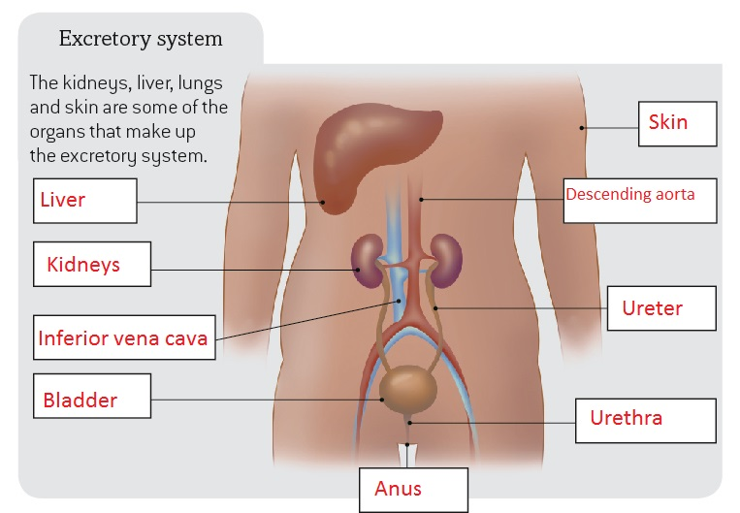

5 Label the main parts of a kidney and nephron.

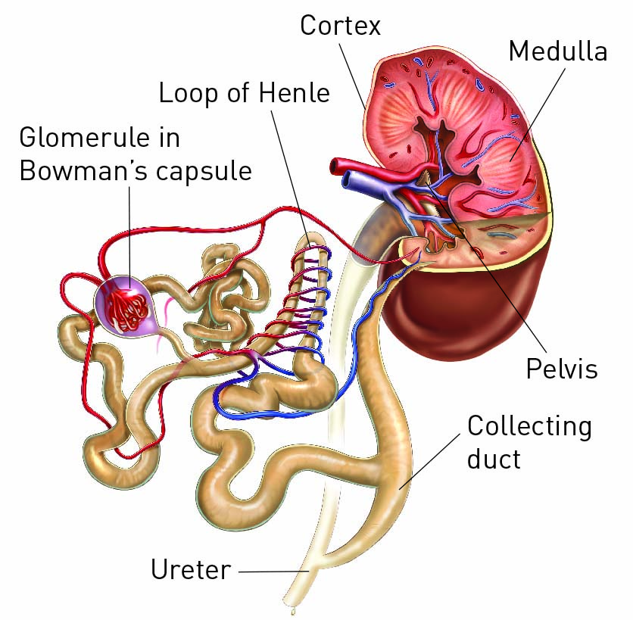

6 What is the function of the liver in the excretion system?

It removes toxins, makes proteins, allows blood to clot, and makes bile

Extend your understanding

If your kidneys do not work properly, removing wastes can be difficult. People with kidney problems may need to undergo frequent treatments, called dialysis, to perform the function that the kidneys cannot.

7 What is the function of the kidney in the excretion system?

It filters waste from the blood and disposes of it through the ureter to the bladder

8 If your kidneys do not work and dialysis must be performed, what is the function of dialysis treatment?

To filter the wastes from the blood that the kidneys are unable to filter

9 Research how dialysis works. Explain this process in very simple terms.

Blood is run through a machine that pumps the blood with a dialysis solution (separated by a membrane). The waste travels from the blood, through the membrane, and into the solution.

10 Is there a cure for kidney failure? Explain what the options are for people whose kidneys shut down permanently.

No, kidney failure is irreversible. For people whose kidneys shut down, the only options available are constant dialysis or a kidney transplant.

7.10 Plants have tissues and organs

Student worksheet answers (pages 134–135)

Plant systems

1 What is the function of roots in a plant?

To anchor the plant to the soil, and to absorb nutrients and water

2 What is the function of the stem in a plant?

To transport water and nutrients between the roots and leaves

3 What is the function of leaves in a plant?

To exchange gases, to produce sugars through photosynthesis, and to control water loss

4 What is the function of the vascular bundle in the stem?

It is the ‘road’ that water and nutrients use to move around the plant

5 What are the two main components of the vascular bundle and what does each do?

Xylem – moves water from roots to leaves

Phloem – moves glucose around the whole plant

6 Label the vascular bundle of a plant stem by identifying the two main components from question 5.

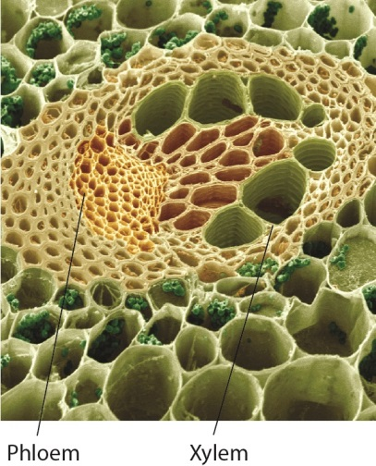

7 Leaves contain specialised structures called stomata. Label the diagram of a stoma below.

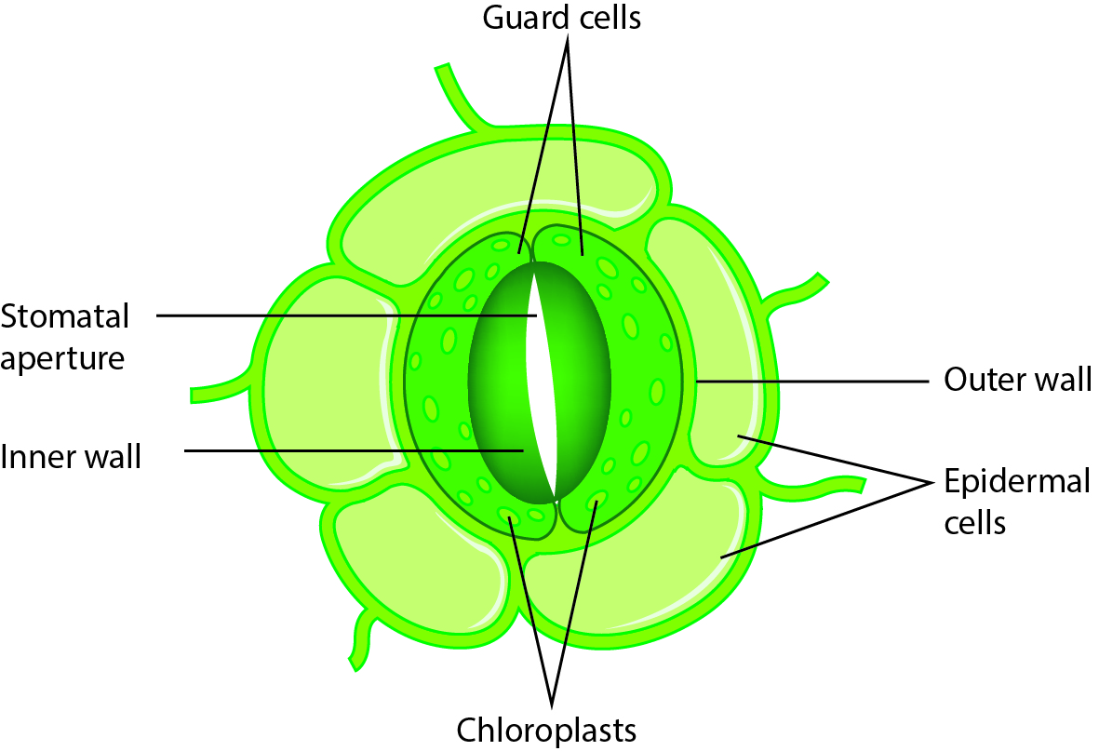

8 What are the main functions of stomata?

To regulate the movement of carbon dioxide, air and water in and out of the cell

Extend your understanding

Guard cells of stomata help to regulate the process of transpiration in plants by opening and closing the stoma (opening). It is the process by which water is carried through the plant to the leaves where it evaporates into the atmosphere through the stomatal pore. When the guard cells are turgid (swollen), the stoma is open; when guard cells are flaccid, the stoma will close.

9 Explain what would happen to the guard cells in a plant in the following situations, and whether the stomatal pore would be open or closed.

a A hot summer day

Guard cells would become flaccid, closing the stomatal pore. This would reduce the loss of water that would occur rapidly on a hot day.

b A cool winter day

Guard cells would become turgid, opening the stomatal pore. This would increase the amount of carbon dioxide in the cells, increasing the rate of photosynthesis.

c A succulent plant in the desert

Stomata would open at night and close during the day. This method decreases transpiration and retains precious water during the hot day so water is not lost.

d A deciduous tree in winter

Leaves fall off trees in autumn, so transpiration does not occur in deciduous trees during winter.